UDC 681.51 (Times New Roman (hereinafter), size 9)

I.I. IVANOV, P.P. PETROV (normal, capitalized, size 9)
(Organization name, city) (size 10, center alignment)
S.S. SIDOROV (Organization name, city)

REQUIREMENTS FOR FORMATTING THE DETAILED ABSTRACTS
IN PROCEEDINGS OF THE CONFERENCE OF YOUNG SCIENTISTS
“NAVIGATION AND MOTION CONTROL” (size 11, center alignment)

The paper title should be followed by an abstract (size 10, italics) where the paper content is briefly described, with the maximum volume of 400 symbols, including spaces. The abstract should be in accordance with the introduction, content and conclusions (left margin 4 cm, paragraph indention 0.5 cm).
The text should be written in Microsoft Word, typed in Times New Roman, size 11, with single line interval. Page size should be А4 (210×297 mm). All margins should be 2.5 cm. Page numbers should be in the bottom center, typed in Times New Roman, size 10.
The volume of detailed abstract should be at least one page, but not more than two pages (up to 6,000 symbols including spaces), beside the list of references.

Introduction. The Introduction should contain brief description of the problem at issue, existing approaches to its solution, and the focus area addressed in the paper. It is important to emphasize all the new things which make the paper original. The Introduction should be in accordance with the paper title. It is recommended to complete this section with a phrase explaining the subject matter of the paper, e.g., “The proposed paper is dedicated to …” The paper text should have a clear structure and contain the title of the main section, conclusions, and list of references.
NB! It is necessary to give a reference to the research supervisor in the footnote on the first page (size 9) (see the footnote below).
Text materials arrangement. The main part should start with clear formulation of the problem and the conditions it is supposed to be solved (the problem formulation can be included in the introduction, if it is not mathematized); the paper content is detailed in this part as well. The main part should have a title and may include subsections. The titles of subsections are written in bold italics within the text, with paragraph indentation made (see the next paragraph as an example).
Formatting the main text. The main text should be typed in Times New Roman, size 11, normal, justified. It is not recommended to insert intervals between paragraphs. Hyphenation is automatic, hyphenation zone is one (1) cm; there should be no more than three successive hyphenations.
Formulas and figures. Formulas should be clearly numbered in succession, with the numbers put in parentheses at the right margin. The formulas should be typed in Equation Editor 3.0, font Times New Roman or Symbol, size 11, superscripts and subscripts – size 9; Latin letters should be typed in italics, while Greek and Cyrillic letters – in normal type.
All variables should be typed in italics both in the formulas and in the text. For example:
$x_{M}^{}$ = arg $\underset{y∈A_{M}}{\text{max}}$ [H(y) – ϑ(y)], (1)
where: H(y) is …..; ϑ(y) is …..;
The formulas should be followed by the word “where” after which all symbols of the formula should be explained.
9
NB! Please make a difference between hyphen and n-dash. Hyphen is an orthographical symbol, while n-dash is a punctuation symbol.
Numbering of figures and tables should be continuous (1, 2, 3 etc., not 1.1, 1.2 etc.).
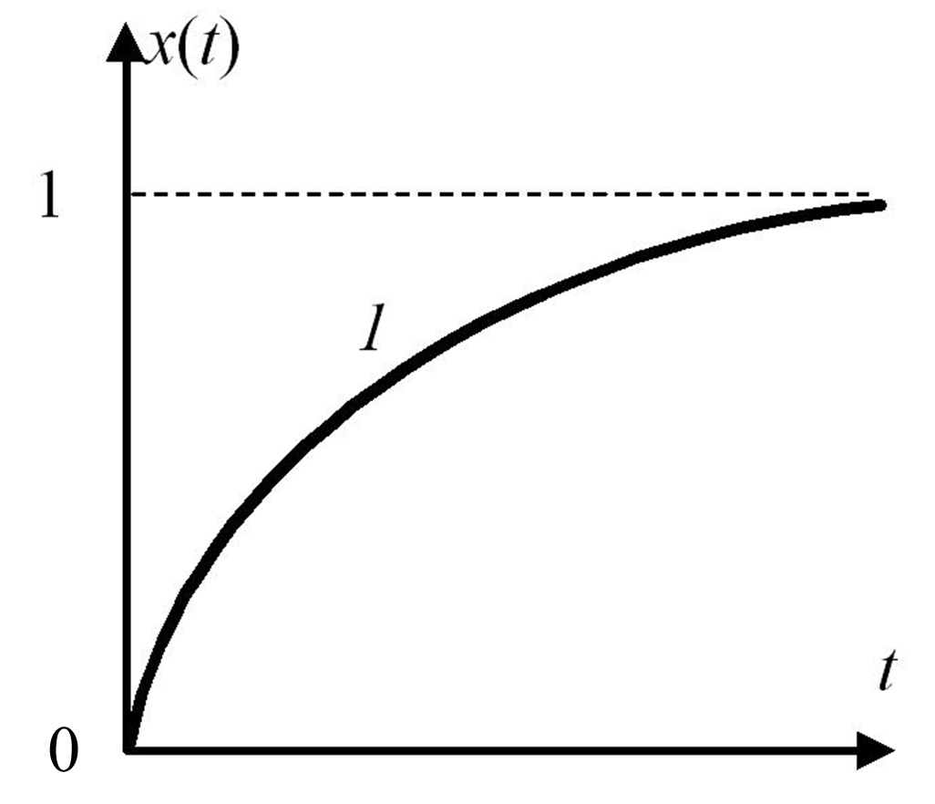
Figure captions should be normal-typed, font size 9. There should be additional empty lines above and below the figures.
Fig. 1. Digits in the figures should be normal-typed, except for curve marks
The figures should be black-and-white only.
Wording in the figures should be clear and readable.
The figures placed in proper places of the text should be in some bitmap format, such as *.tif, *.bmp, or *.jpg.
NB! Each figure, diagram, and graph should be a single piece, with a possibility to change its scale and position without damaging the image integrity.

T a b l e 1 (size 9, spaced-out)
Website www.mtas.ru visit statistics (size 9)
Month | Number of visitors
September 2005 | 1,880
October 2005 | 3,082
November 2005 | 3,535
December 2005 | 3,332
January 2006 | 2,764

The tables should have center alignment. Above the table caption, type spaced-out word “Table” with relevant number, and with right alignment. Below, type the table caption in bold, size 9, center-aligned. The table should be separated from the text below it with an empty line. The table should be within the printing envelope. Text in the cells should be typed with font size 9; text positioning depends on the content: figures are aligned by decimal point, single words are center-aligned, and sentences are justified. There should be no full stop in the end of text in each cell.
Decimals should be typed with a decimal point, such as 1.5.
Abbreviations. It is permitted to use at most three abbreviations in the paper text, which should be expanded when mentioned for the first time.
Conclusions. The Conclusions section contains comments on the obtained results, and specifies possible directions for further research as expected. The Conclusions section should be in accordance with the Abstract, Introduction, and the main text of the paper.
If the work was performed under the auspices of some organization, it should be referred to in the end of the paper, e.g.: The work was performed under the auspices of …
(italics, size 11, center alignment)

references

Caption of the REFERENCES section should be typed in Times New Roman, size 9, capitalized, center-aligned, with one empty line made above and below the section.
The authors should be listed in alphabetic order, Russian authors first, then international authors. The list should be numbered, typed with font size 9.
In the paper text, the references to relevant sources should be marked with corresponding numbers in brackets, e.g.: [5].

- Ivanov, I.I., Osnovy teorii poznaniya (Fundamentals of Epistemology), Moscow, Nauka, 1999, 257 p.
- Ivanov, I.I., Petrov, P.P., and Sergeev, S.S., Мodelirovanie povedeniya (Behaviour Modelling), Moscow, Nauka, 1985, pp. 57–59.
- Johnson, L.M., Modelling, Science, 1998, vol. 2, no. 3, pp. 13–17.

After the list of References, it is necessary to present the following information in English: authors, their organizations, cities, paper title, and abstract.

I.I.Ivanov, P.P.Petrov (normal type, font size 11), (Company, city), and S.S.Sidorov (Company, city)
Requirements to formatting the detailed abstract in the proceedings of the Conference of Young Scientists “Navigation and Motion Control” (bold type, font size 11, justified)

Abstract in English can be a translation of the Russian abstract or an extended version of it. Use Times New Roman, normal type, font size 11, justified.

WARNING!

In the end of the detailed abstract text, there must be the following sentence:
The text of this detailed abstract has been approved by the Research Supervisor.
Name, company and academic rank of the Research Supervisor should be specified along with his/her signature.

NB! The text will not be published if it is not signed by the Research Supervisor.
In case you do not have a Research Supervisor, please write the following:
The work has been performed independently.

 Research supervisor: Name, second name, family name, academic rank, job position.

