УДК 681.51 (Times New Roman (hereinafter), font size 9)

I. I. IVANOV, P. P. PETROV (normal type, capital letters, font size 9)
(Name of organization, city) (font size 10, center alignment)
S.S. SIDOROV (Name of organization, city)

REQUIREMENTS FOR FORMATTING DETAILED ABSTRACTS
FOR THE PROCEEDINGS OF THE CONFERENCE OF YOUNG SCIENTISTS "NAVIGATION AND MOTION CONTROL" (font size 11, center alignment)
NB! Never use abbreviations in the title!

The title of paper should be followed by an abstract (font size 10, italics) comprising maximum 400 symbols including spaces, which briefly describes the main point of the paper. The abstract should be in line with the introduction, paper content, and conclusion (shift from the left margin is 4 cm, paragraph indention is 0.5 cm).
The paper text should be written in Microsoft Word, font Times New Roman, font size 11, single line spacing (1.0). Paper size is А4 (210×297 mm.). Each margin is 2.5 cm wide. Page numbers should be located in the center at the foot of the page. Page numbers should be typed in Times New Roman, font size 10.
Full text of the detailed abstract should be not less than 1 and not more than 2 pages (up to 6,000 characters including spaces), not including the List of references.

Introduction. The introduction is a summary of the general problem, existing solutions, and the area of the paper focus. It is important to emphasize new features which make the paper original. The introduction should be in line with the title. It is recommended that its final sentence explains the subject matter of the paper, e.g.: "In this paper, .... is/are addressed.” The text of the paper should have a clear structure and include the text body title, conclusion, list of references.
NB! The research supervisor should be mentioned as a reference in the footnote on the first page (font size 9) (see also at the end of the text).
Text layout. The text body starts with formulating the problem and the conditions of its expected solution (the problem formulation can be included in the introduction if it is not mathematized); the content of the paper is further developed in this part as well. Preferably, the text body should be headed and contain subsections. Titles of subsections should be written within the text, with paragraph indention, in bold italic. (see the next paragraph as an example).
Text body formatting. The text body should be typed in Times New Roman, font size 11, light face, full justification. Paragraph indention is 0.5 cm. It is not recommended to insert an interline spacing between the paragraphs. Hyphenation: self-instructed carry, hyphenation zone – 1 cm, no more than three sequential carries.
Formulas and figures. The formulas should have order numbers in parentheses at the right margin. Equation Editor 3.0 should be used for formula typing; font Times New Roman or Symbol, font size 11; font size 9 for superscripts and subscripts; Latin letters are typed in italics, while Greek and Cyrillic letters - in normal type.
All variables should be typed in italics both in the formulas and in the text. For example:
$x_{M}^{}$ = arg $\underset{y∈A_{M}}{\text{max}}$ [H(y) – ϑ(y)], (1)
where: H(y) − …..; ϑ(y) − …..;
The word "where" should follow the formula, after which all symbols of the formula are explained.
9
NB! Hyphen and en-dash should be distinguished. Hyphen (-) is an orthographic symbol, while en-dash (−) is a punctuation symbol.
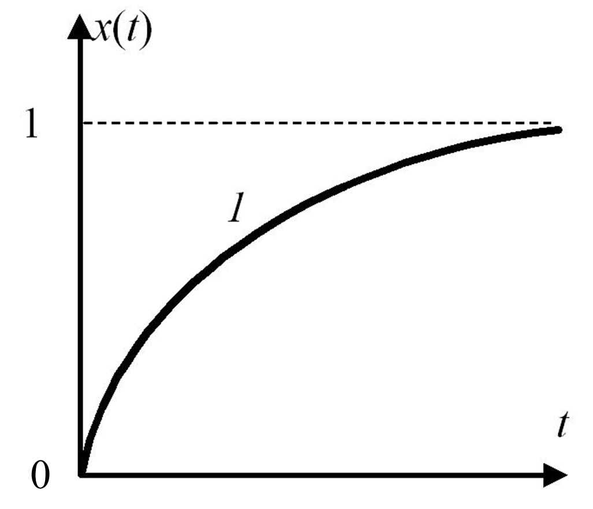
Figures and tables should have continuous numbering (1, 2, 3 etc., rather than 1.1, 1.2 etc.).
Fig. 1.
Numbers in the figure should be of direct lettering, except for designation of curves
Captions under figures should be typed in the base font, size 9. The figure should be isolated with additional empty lines above and below.
The figures should be black-and-white only.
Notations in the figures should be clear and readable.
Figures made in some bit map format (*.tif, *.bmp, or *.jpg) should be placed in relevant places in the text.
NB! Each figure, diagram, or graph should be inserted as a single piece, to enable their scaling and re-location without damaging the image integrity.
T a b l e 1 (font size 9, spaced-out)
Web-site www.mtas.ru traffic statistics (font size 9)
Month | Number of visitors
September 2005 | 1880
October 2005 | 3082
November 2005 | 3535
December 2005 | 3332
January 2006 | 2764

Tables should be located in the page center. Above the table title, spaced-out word "table" with corresponding number should be typed with right alignment. Then the title of the table is typed in bold, font size 9, center-aligned. An empty line should follow below the table. The table margins should lie within the printable area. Text in the table cells should be printed with font size 9; the text location depends on the content: the numbers are aligned by comma, individual words are center-aligned, and sentences are full-justified. Point is not put at the end of sentences in each cell.
Decimals should be separated by decimal points, e.g.: 1.5.
Abbreviations. All abbreviations in the title should be expanded. It is permitted to use maximum three abbreviations in the text, and those should be expanded when mentioned for the first time.
Conclusion The conclusion provides comments on the research findings and specifies possible directions of further investigations to be undertaken. The conclusion should be in concordance with the abstract, introduction, and body of the paper.
If the research was supported by any organization, it should be mentioned at the end of the paper text
(E.g.: The work was sponsored by the RFBR grant xx-xx-xxxxx)
(italics, font size 11, center-aligned)

REFERENCES

The title of REFERENCES part should be typed in Times New Roman, font size 9, in capital letters, center-aligned, with one empty line inserted above and below the title.
The reference sources should be listed sequentially as they appear in the text. The list should be numbered, and typed in font size 9.
In the text, references to relevant sources are made as the corresponding numbers put in square brackets, e.g., [5].

- Ivanov, I.I, Fundamentals of Gnoseology, Moscow, Nauka, 1999, pp. 257.
- Ivanov, I.I., Petrov, P.P., and Sergeev, S.S. Behaviour Modeling, Moscow, Nauka, 1985, pp. 57–59.
- Johnson, L.M. Modelling, Science, 1998 Vol. 2 №3 P. 13–17.

After the References, the following information in English should be provided: author(s), organization, city, paper title, and abstract.

Ivanov, I.I., Petrov, P.P., (normal type, font size 11), (Company, city), and Sidorov, S.S. (Company, city)
Requirements for formatting papers for the Conference of Young Scientists “Navigation and Motion Control” (bold type, font size 11, justified)

Abstract in English can be a translation of the Russian abstract or an extended version of it. Use Times New Roman, normal type, font size 11, justified.

WARNING!

The text of the paper should be approved by the research supervisor!
Indicate the research supervisor’s initials, place of work and academic rank, and affix his signature.

NB! The paper will not be published if not signed by the research supervisor.
If there is no research supervisor, the paper should contain the following:
"The work has been performed at the author's own initiative."

Before submitting the paper, we recommend to check it for compliance with our requirements using the check-list in the table below. If you have to give a negative answer to at least one of the following questions, the paper in its current format is likely to be returned for revision.

N | Question | Yes/No
1 | Does the text structure include abstract, introduction, sections, and conclusion?
2 | Is the paper title in line with the abstract?
3 | Is the paper title in line with the introduction?
4 | Is the paper title in line with the conclusion?
5 | Is the abstract in line with the introduction?
6 | Is the abstract in line with the conclusion?
7 | Is the introduction in line with the conclusion?
8 | Does the introduction contain a final paragraph or phrase explaining the subject matter of the paper?
9 | Are the punctuation symbols after formulas put properly?
10 | Are all given designations and variables explained immediately after the formulas?
11 | Do the figure descriptions in the text correspond to figure captions?
12 | Is the list of references complete enough?
13 | Does the text contain references to all sources from the List of References?
14 | Are abbreviations avoided in the paper title?
15 | Are all abbreviations expanded in the text, and is the number of abbreviations less than three, as required?

 Research supervisor :First name(s), Surname, academic rank, job position.

